2 Minute Form
Trip Name: Milford to Coastguard Bay, Rangitoto
Check-in Name and Phone: Rob Howarth 021 925 489
Date: 5 Apr 2014 Branch: North Shore
Leaders | Joya Todd
Cell Phone Number | 021 046 9036
VHF Call Sign &/or Vessel Name | ZMT 6745
Vehicle make, model, registration, colour | Mazda Capella wagon |  | Sikver/grey DTS145
General Plan  Note: If plan changes, you must notify your Check-in person. | 10:00 meet at Craig Rd, Milford car park  10:30 on the water  11:30 loo stop at McKenzie Bay  12:30 lunch at Coastguard Bay (no loos available)  13:30 return  14:30 loo stop if necessary McKenzie Bay  15:30 Milford
Latest Time Off the Water | 16:30 |  |  |  | TMP/ AMP used²⁰ | Milford to Coastguard Bay Rangitoto
Tide/ Forecast Lake Level | Low 06:05 |  |  | High12:31 | Other
Communications Carried²¹ | Mob, VHF, Epirb
Communications | We will be communicating as a group on VHF Channel __8___
Equipment Carried | Usual day kit
Trip Report
(Use other side if more space required)

Activity |  |  | Strong beginners paddle |  |  |  | Centre | North Shore |  | Location |  |  |  |  |  |  | Difficulty¹ |  |  |  |  | Strong beginner
Activity Description |  |  | Milford to Coastguard Bay, Rangitoto |  |  |  |  |  |  |  | Leader qualification req.² |  |  |  | NZKI 2*
Get in Location |  |  | Craig Rd, Milford |  |  |  |  |  |  |  | Chart/ Map no.⁴ |  |  |  | 5321 |  | Distance |  |  |  |  | 15-18 km
Get out Location |  |  | ditto |  |  |  |  |  |  |  | Coastguard Channel |  |  |  | 82 & 16 |  | Nowcasting |  |  |  |  | 21
Emergency get out ⁵ |  |  | North Shore coastline. Bays on Rangitoto. |  |  |  |  |  |  |  | Emergency / Coastguard Station |  |  |  | Auckland |  | Phone |  |  |  |  | *500  09 303 4303
 |  |  |  |  |  |  |  |  |  |  | Drinking Water⁶ |  | Milford only |  |  | Toilets⁷ |  |  |  | Milford, McKenzie Bay only
Emergency Response |  |  | Refer Emergency Response Booklet |  |  |  |  |  |  |  |  |  |  |  |  | Parking⁸ |  |  |  | Craig Rd, Milford
Specific Equipment Required⁹ |  |  | High vis clothing. |  |  |  |  |  |  |  | Working Communications equipment in this area¹⁰ |  | Cell phone  Sat phone |  |  |  |  |  |  |  |  |  | PLB  VHF
Other resources  and notes¹¹ |  |  |  |  |  |  |  |  |  |  | Weather Parameters¹² |  | 15 kn in exposed areas  2m surf Wave faces on beaches
Previous incidents¹³
Safety Management¹⁴
Hazard |  | Significant? |  |  | Management Strategy¹⁵ |  |  |  |  |  | Hazard | Significant? |  | Management Strategy¹⁵
Cold Water |  | Yes |  |  | Carry spare dry clothes and shelter |  |  |  |  |  | Deep Water | Yes |  | Correctly fit PFDs
Medical Conditions |  | Yes |  |  | - Leader has first aid qualification  - Ask customers about medical conditions |  |  |  |  |  | Bad Weather | Yes |  | Understand weather forecasts.  Have back up plans or pull out if necessary
Capsizing |  | Yes |  |  | - Correctly fit Pfds  - Skills at performing rescues. |  |  |  |  |  | Heat / Sun | Yes |  | - Protective Clothing (worn)  - Sun Screen  - Plenty of drinks  - Sunglasses
Panic |  | Yes |  |  | Ensure conditions match level  of skills |  |  |  |  |  | Obstacles | Ye s |  | Awareness of reefs, navigational hazards, nets
Current |  |  |  |  | - Travel with tide |  |  |  |  |  | Other Vessels | Yes |  | - Understand the “rules of the sea”  - “Be seen” – Have two of the following; flag, brightly coloured kayak, brightly coloured Pfd or hat. At night: an all round white light & a powerful torch.
Other Hazards |  | Yes |  |  | Surf – launching and landing – rare for surf to be a problem on east coast beaches but it can happen. Assist beginners paddling out and carry out surf management coming in. |  |  |  |  |  | Other Hazards
Written up by: | Joya Todd |  |  | Approved By: |  | Rob Howarth |  |  | Signed: |  |  | Date: |  | 4/4/2014 |  |  |  | Review in: |  |  | 12 months from date of approval

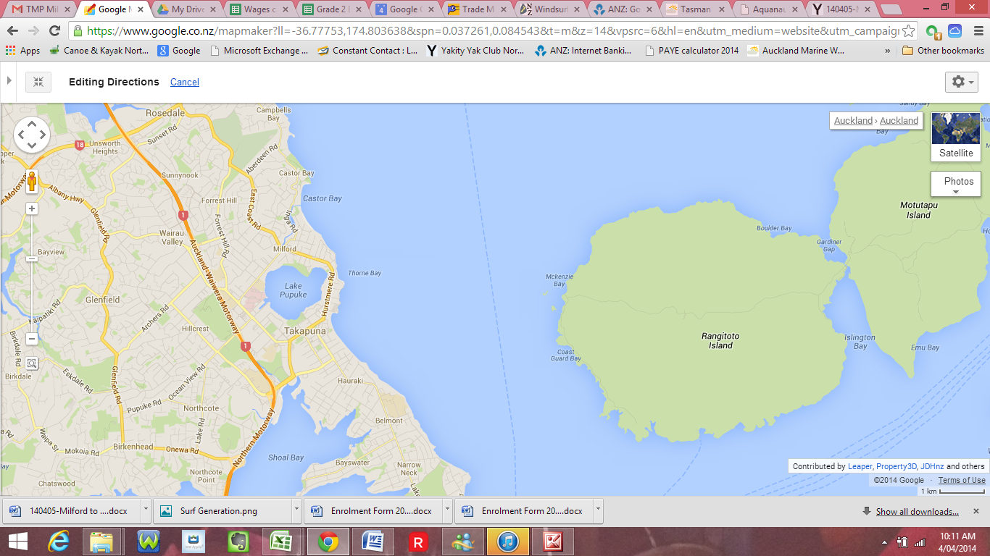

Activity Equipment Check list
Equipment List
- Helmet (rivers & surf) Group Gear
❑ Beanie / hat  Split paddles
❑ Thermals  Repair kit
❑ Paddle Jacket  Fire lighting
❑ PFD  Cooker/thermos
❑ Spray deck  Spare thermals
❑ Booties  Tow system
❑ Water & food  1st Aid Kit
❑ Kayak & paddle  Flares
Group - Oceans & Lakes  Compass
❑ Pumps & Paddle Floats  Charts / Maps
Group - River  GPS (optional)
❑ Throw ropes  Knife (cut rope)
❑ Pin kit & saw  Emergency Shelter

In case of emergency: Dial 111, Mayday :VHF Channel 16

Kayaking Check list

❑ Trip plan
❑ Latest weather forecast
❑ Conditions match skills?
❑ Hyperthermia (hot) &
Hypothermia (cold)
❑ On & off water safety
❑ Environmental concerns
❑ Emergency Procedures include emergency get out.
❑ Working communication devices
e.g. VHF radio, mobile phones, PLB
❑ Specific safety issues for this trip
❑ Participant list
❑ Any medical conditions
❑ All participants keen to proceed?

❑ Trip Plan/ 2-minute form lodged with Ops. Manager

Appropriate wind conditions to run trips:
Novice - no significant surf or swell, wind under 15knots
Intermediate- surf or ocean swells less than 1.5 meter or wind under 25 knots.
Advanced- any condition that is suitable to the trips aims

At conclusion of trip:
Contact check in person
Group Debrief.

Check in Person Ph:
__________________ Mobile
__________________ Work
__________________ Home

Activity Document Cover Sheet

Activity:
Date of Activity:

Activity reports. Is all relevant information present:
– Approved Trip Management Plan (TMP)/ 2 minute form
– Club Trip Participant Sheet
– Weather forecast
– Activity Check List
– Trip report (May be on the 2 minute form)
– Accident / incident reports
Leaders Signature:
Date:

